Name of work
Autor 1¹, Autor 2²
¹ Name of the organization, Сountry
² Name of the organization, Сountry
e-mail: autor_of_work@gmail.com

Margins on the left 2.5, right 1.5, top 2, bottom 2. The main text of the work: font 12 (Times New Roman); single spacing; indentation of the first line 1.25; width alignment. Title of the work: font 14 (Times New Roman) bold; single spacing; center alignment. Authors: font 12 (Times New Roman); single spacing; center alignment. Name of organizations: font 10 (Times New Roman) italics; single spacing; center alignment. The drawings are centered. Figure captions: font 10 (Times New Roman); single spacing; center alignment. Table captions: font 10 (Times New Roman); interval single; right alignment. The volume is not more than 1 page.

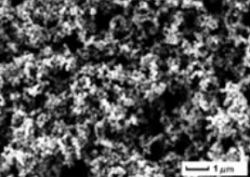
Fig.1. SEM for Ni-nanoparticles

Table 1 - Number of cats
№ | Exemple 1 | Exemple 2
1 | 0.15 | 1.4*10⁹
… | … | …

References
1. Research of Nanostructured Carbon Felt Materials as Electrodes of Vanadium Flow Batteries / V. A. Komarov, A. N. Voropay, M. N. Il’ina and T. V. Goryacheva // Russian Journal of Electrochemistry 57 (2021) 485-491
.

